Лабораторна робота №4

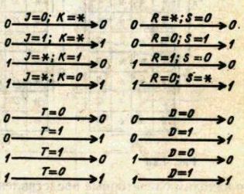Варіант 0100010

Частина 1

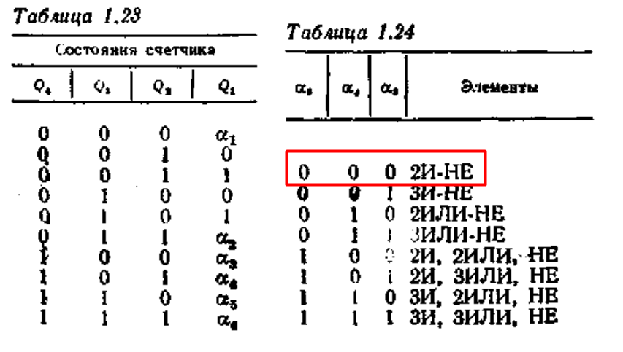

|  |  |  |  |  |  |  |  |  |  |  |  |  |  |  |  |
| --- | --- | --- | --- | --- | --- | --- | --- | --- | --- | --- | --- | --- | --- | --- | --- |
| Q4 | Q3 | Q2 | Q1 | Q4S+1 | Q3S+1 | Q2S+1 | Q1S+1 | T4 | T3 | T2 | T1 | J4 | K4 | J3 | K3 |
| 0 | 0 | 0 | 0 | 0 | 0 | 1 | 0 | 0 | 0 | 1 | 0 | 0 | * | 0 | * |
| 0 | 0 | 1 | 0 | 0 | 0 | 1 | 1 | 0 | 0 | 0 | 1 | 0 | * | 0 | * |
| 0 | 0 | 1 | 1 | 0 | 1 | 0 | 0 | 0 | 1 | 1 | 1 | 0 | * | 1 | * |
| 0 | 1 | 0 | 0 | 0 | 1 | 0 | 1 | 0 | 0 | 0 | 1 | 0 | * | * | 0 |
| 0 | 1 | 0 | 1 | 0 | 1 | 1 | 1 | 0 | 0 | 1 | 0 | 0 | * | * | 0 |
| 0 | 1 | 1 | 1 | 1 | 0 | 0 | 0 | 1 | 1 | 1 | 1 | 1 | * | * | 1 |
| 1 | 0 | 0 | 0 | 1 | 0 | 1 | 0 | 0 | 0 | 1 | 0 | * | 0 | 0 | * |
| 1 | 0 | 1 | 0 | 1 | 1 | 0 | 0 | 0 | 1 | 1 | 0 | * | 0 | 1 | * |
| 1 | 1 | 0 | 0 | 1 | 1 | 1 | 1 | 0 | 0 | 1 | 1 | * | 0 | * | 0 |
| 1 | 1 | 1 | 1 | 0 | 0 | 0 | 0 | 1 | 1 | 1 | 1 | * | 1 | * | 1 |

|  |  |  |  |  |  |  |  |  |  |  |  |  |  |  |  |
| --- | --- | --- | --- | --- | --- | --- | --- | --- | --- | --- | --- | --- | --- | --- | --- |
| Q4 | Q3 | Q2 | Q1 | Q4S+1 | Q3S+1 | Q2S+1 | Q1S+1 | J2 | K2 | J1 | K1 | D4 | D3 | D2 | D1 |
| 0 | 0 | 0 | 0 | 0 | 0 | 1 | 0 | 1 | * | 0 | * | 0 | 0 | 1 | 0 |
| 0 | 0 | 1 | 0 | 0 | 0 | 1 | 1 | * | 0 | 1 | * | 0 | 0 | 1 | 1 |
| 0 | 0 | 1 | 1 | 0 | 1 | 0 | 0 | * | 1 | * | 1 | 0 | 1 | 0 | 0 |
| 0 | 1 | 0 | 0 | 0 | 1 | 0 | 1 | 0 | * | 1 | * | 0 | 1 | 0 | 1 |
| 0 | 1 | 0 | 1 | 0 | 1 | 1 | 1 | 1 | * | * | 0 | 0 | 1 | 1 | 1 |
| 0 | 1 | 1 | 1 | 1 | 0 | 0 | 0 | * | 1 | * | 1 | 1 | 0 | 0 | 0 |
| 1 | 0 | 0 | 0 | 1 | 0 | 1 | 0 | 1 | * | 0 | * | 1 | 0 | 1 | 0 |
| 1 | 0 | 1 | 0 | 1 | 1 | 0 | 0 | * | 1 | 0 | * | 1 | 1 | 0 | 0 |
| 1 | 1 | 0 | 0 | 1 | 1 | 1 | 1 | 1 | * | 1 | * | 1 | 1 | 1 | 1 |
| 1 | 1 | 1 | 1 | 0 | 0 | 0 | 0 | * | 1 | * | 1 | 0 | 0 | 0 | 0 |

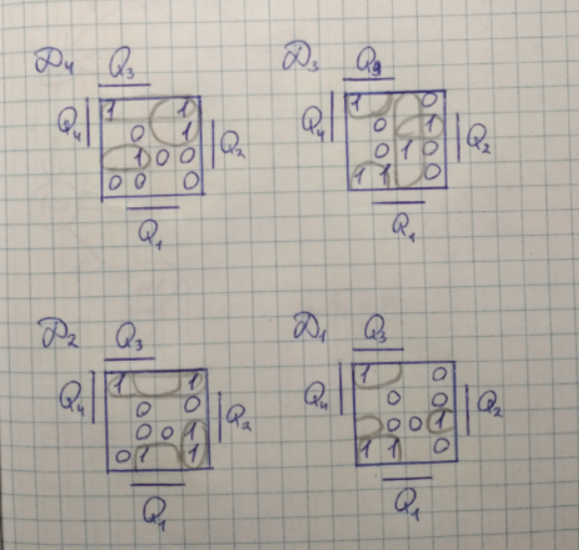Діаграми Вейча:

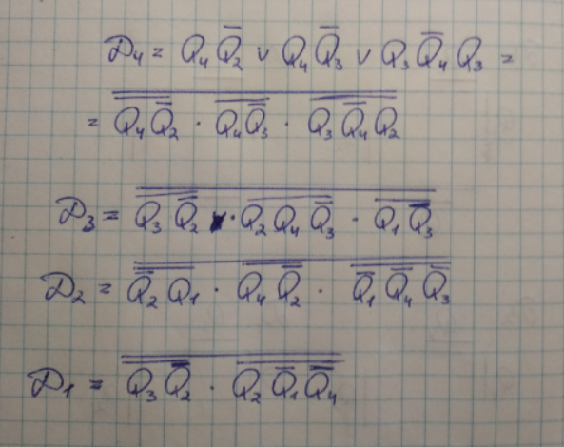

Частина 2

a5 a4 a3 a2 a1 = 00010

|  |  |  |  |  |  |  |  |  |  |  |  |  |  |  |  |
| --- | --- | --- | --- | --- | --- | --- | --- | --- | --- | --- | --- | --- | --- | --- | --- |
|  | Q5 | Q4 | Q3 | Q2 | Q1 | Q5S+1 | Q4S+1 | Q3S+1 | Q2S+1 | Q1S+1 | T5 | T4 | T3 | T2 | T1 |
|  | 0 | 0 | 0 | 0 | 0 | 0 | 0 | 0 | 0 | 1 | 0 | 0 | 0 | 0 | 1 |
| A | 0 | 0 | 0 | 0 | 1 | 0 | 0 | 0 | 1 | 0 | 0 | 0 | 0 | 1 | 1 |
| B | 0 | 0 | 0 | 1 | 0 | 0 | 0 | 0 | 1 | 1 | 0 | 0 | 0 | 0 | 1 |
| C | 0 | 0 | 0 | 1 | 1 | 0 | 0 | 1 | 0 | 0 | 0 | 0 | 1 | 1 | 1 |
|  | 0 | 0 | 1 | 0 | 0 | 0 | 0 | 1 | 0 | 1 | 0 | 0 | 0 | 0 | 1 |
|  | 0 | 0 | 1 | 0 | 1 | 0 | 0 | 1 | 1 | 0 | 0 | 0 | 0 | 1 | 1 |
|  | 0 | 0 | 1 | 1 | 0 | 0 | 0 | 1 | 1 | 1 | 0 | 0 | 0 | 0 | 1 |
|  | 0 | 0 | 1 | 1 | 1 | 0 | 1 | 0 | 0 | 0 | 0 | 1 | 1 | 1 | 1 |
|  | 0 | 1 | 0 | 0 | 0 | 0 | 1 | 0 | 0 | 1 | 0 | 0 | 0 | 0 | 1 |
|  | 0 | 1 | 0 | 0 | 1 | 0 | 1 | 0 | 1 | 0 | 0 | 0 | 0 | 1 | 1 |
|  | 0 | 1 | 0 | 1 | 0 | 0 | 1 | 0 | 1 | 1 | 0 | 0 | 0 | 0 | 1 |
|  | 0 | 1 | 0 | 1 | 1 | 0 | 1 | 1 | 0 | 0 | 0 | 0 | 1 | 1 | 1 |
|  | 0 | 1 | 1 | 0 | 0 | 0 | 1 | 1 | 0 | 1 | 0 | 0 | 0 | 0 | 1 |
|  | 0 | 1 | 1 | 0 | 1 | 0 | 1 | 1 | 1 | 0 | 0 | 0 | 0 | 1 | 1 |
|  | 0 | 1 | 1 | 1 | 0 | 0 | 1 | 1 | 1 | 1 | 0 | 0 | 0 | 0 | 1 |
|  | 0 | 1 | 1 | 1 | 1 | 1 | 0 | 0 | 0 | 0 | 1 | 1 | 1 | 1 | 1 |
|  | 1 | 0 | 0 | 0 | 0 | 1 | 0 | 0 | 0 | 1 | 0 | 0 | 0 | 0 | 1 |
|  | 1 | 0 | 0 | 0 | 1 | 1 | 0 | 0 | 1 | 0 | 0 | 0 | 0 | 1 | 1 |
|  | 1 | 0 | 0 | 1 | 0 | 1 | 0 | 0 | 1 | 1 | 0 | 0 | 0 | 0 | 1 |
|  | 1 | 0 | 0 | 1 | 1 | 1 | 0 | 1 | 0 | 0 | 0 | 0 | 1 | 1 | 1 |
|  | 1 | 0 | 1 | 0 | 0 | 1 | 0 | 1 | 0 | 1 | 0 | 0 | 0 | 0 | 1 |
|  | 1 | 0 | 1 | 0 | 1 | 1 | 0 | 1 | 1 | 0 | 0 | 0 | 0 | 1 | 1 |
|  | 1 | 0 | 1 | 1 | 0 | 1 | 0 | 1 | 1 | 1 | 0 | 0 | 0 | 0 | 1 |
|  | 1 | 0 | 1 | 1 | 1 | 1 | 1 | 0 | 0 | 0 | 0 | 1 | 1 | 1 | 1 |
|  | 1 | 1 | 0 | 0 | 0 | 1 | 1 | 0 | 0 | 1 | 0 | 0 | 0 | 0 | 1 |
|  | 1 | 1 | 0 | 0 | 1 | 1 | 1 | 0 | 1 | 0 | 0 | 0 | 0 | 1 | 1 |
|  | 1 | 1 | 0 | 1 | 0 | 1 | 1 | 0 | 1 | 1 | 0 | 0 | 0 | 0 | 1 |
|  | 1 | 1 | 0 | 1 | 1 | 1 | 1 | 1 | 0 | 0 | 0 | 0 | 1 | 1 | 1 |
|  | 1 | 1 | 1 | 0 | 0 | 1 | 1 | 1 | 0 | 1 | 0 | 0 | 0 | 0 | 1 |
|  | 1 | 1 | 1 | 0 | 1 | 1 | 1 | 1 | 1 | 0 | 0 | 0 | 0 | 1 | 1 |
|  | 1 | 1 | 1 | 1 | 0 | 1 | 1 | 1 | 1 | 1 | 0 | 0 | 0 | 0 | 1 |
|  | 1 | 1 | 1 | 1 | 1 | 0 | 0 | 0 | 0 | 0 | 1 | 1 | 1 | 1 | 1 |

fA =

T5 = Q4Q3Q2Q1 = T5*

T4 = Q3Q2Q1 = T4*

T3 = Q2Q1 = T3*

T2 = Q1 = T2*

T1 = 1

T1* =

Частина 3

